**Title: Smart Trash Detector and Trash Level Detector System**

**Team Members: Prerana Samant, Zeal Patel, Ashish Pant**

**Introduction**

Waste management is critical to maintaining proper hygiene in the surrounding. Recycling is important to prevent elements like plastic from deteriorating the environment. Waste if sorted into proper categories like 1. organic waste 2. Recyclable waste then it is easy to recycle the materials and dispose of the organic waste to generate compost. This project will have two aspects. The first feature will distinguish between the type of garbage after scanning the object and the second feature will detect when the garbage bin is full and send an indication to the centralized garbage management system.

**Motivation**

We got this motivation after observing in the college cafeteria that the students throw the trash into bins without looking at the appropriate category. They throw all the waste items into a single bin. This is cumbersome for the garbage management system to sort the items after collecting the trash. Hence, a smart system will help people to dispose of the waste into proper bins. This will lead to proper recycling of waste and organic waste can be processed to create biofuels and compost.

**Goals and Objective**

Our goal is to implement a smart trash detector to make the garbage management system more effective. Our object is to build a basic model first which will sort the trash into just two categories. Based on the type of trash it will detect it's type and indicates the smart bin which lid to open for discarding the item. The second objective is to detect if the bin is full and indicate the management system with a notification indicating the need to empty the bin.

**Features**

1. Garbage type detection- organic waste or recyclable
2. Android app- Use the camera of mobile phone to click the image of the trash item
3. Machine-learning models to detect the type of trash
4. Wireless connectivity of Android mobile with Arduino
5. Ultrasonic sensor- Detect if the garbage bin is full
6. Notification-Give alert e-mail to the garbage management system for emptying the bin.

**Block Diagram**

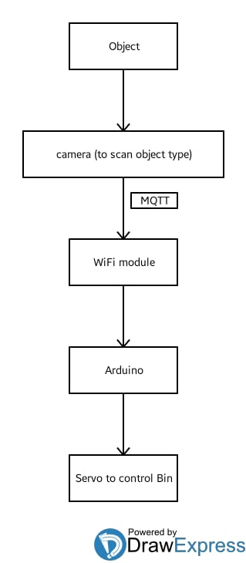

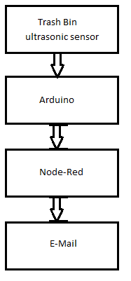

**Implementation Plan**

1. We will be developing an Android app which will have access to a phone camera. The camera will click an image of the trash item and it will compare with the model data to distinguish into either organic waste or recyclable category.
2. The Android app will be developed using MIT app inventor 2. Once the category is figured out by the app, it will indicate the Arduino of the type of trash using Bluetooth or WiFi connection.
3. Arduino will turn on the respective motor depending upon the input from the Arduino app. The motors will open the lid of the respective garbage bin. For. eg. if the item detected by the app is plastic bottle then it will open the recyclable bin out of the two bins.
4. We will also be using an ultrasonic sensor to detect if the garbage bin is full. When the garbage is full, it will indicate the Arduino through and Arduino will communicate with Node-Red to send an alert E-mail to the garbage management system.

**Application**

This system can be used at any public places like colleges, movie theatres, bus/railway stations, etc. It can be further improved to add more data samples to detect the type of trash. It can also be extended to have more defined categories.

**References**

1. [Smart_Dustbin](https://www.hackster.io/mohd-shahid/smart-dustbin-using-arduino-c0bb7a)
2. [SmartGarbageMonitoringSystem](https://www.instructables.com/id/Smart-Garbage-Monitoring-System-Using-Internet-of-/)
3. We will be using all the learnings from Module 1 ICPs for the implementation of the project.